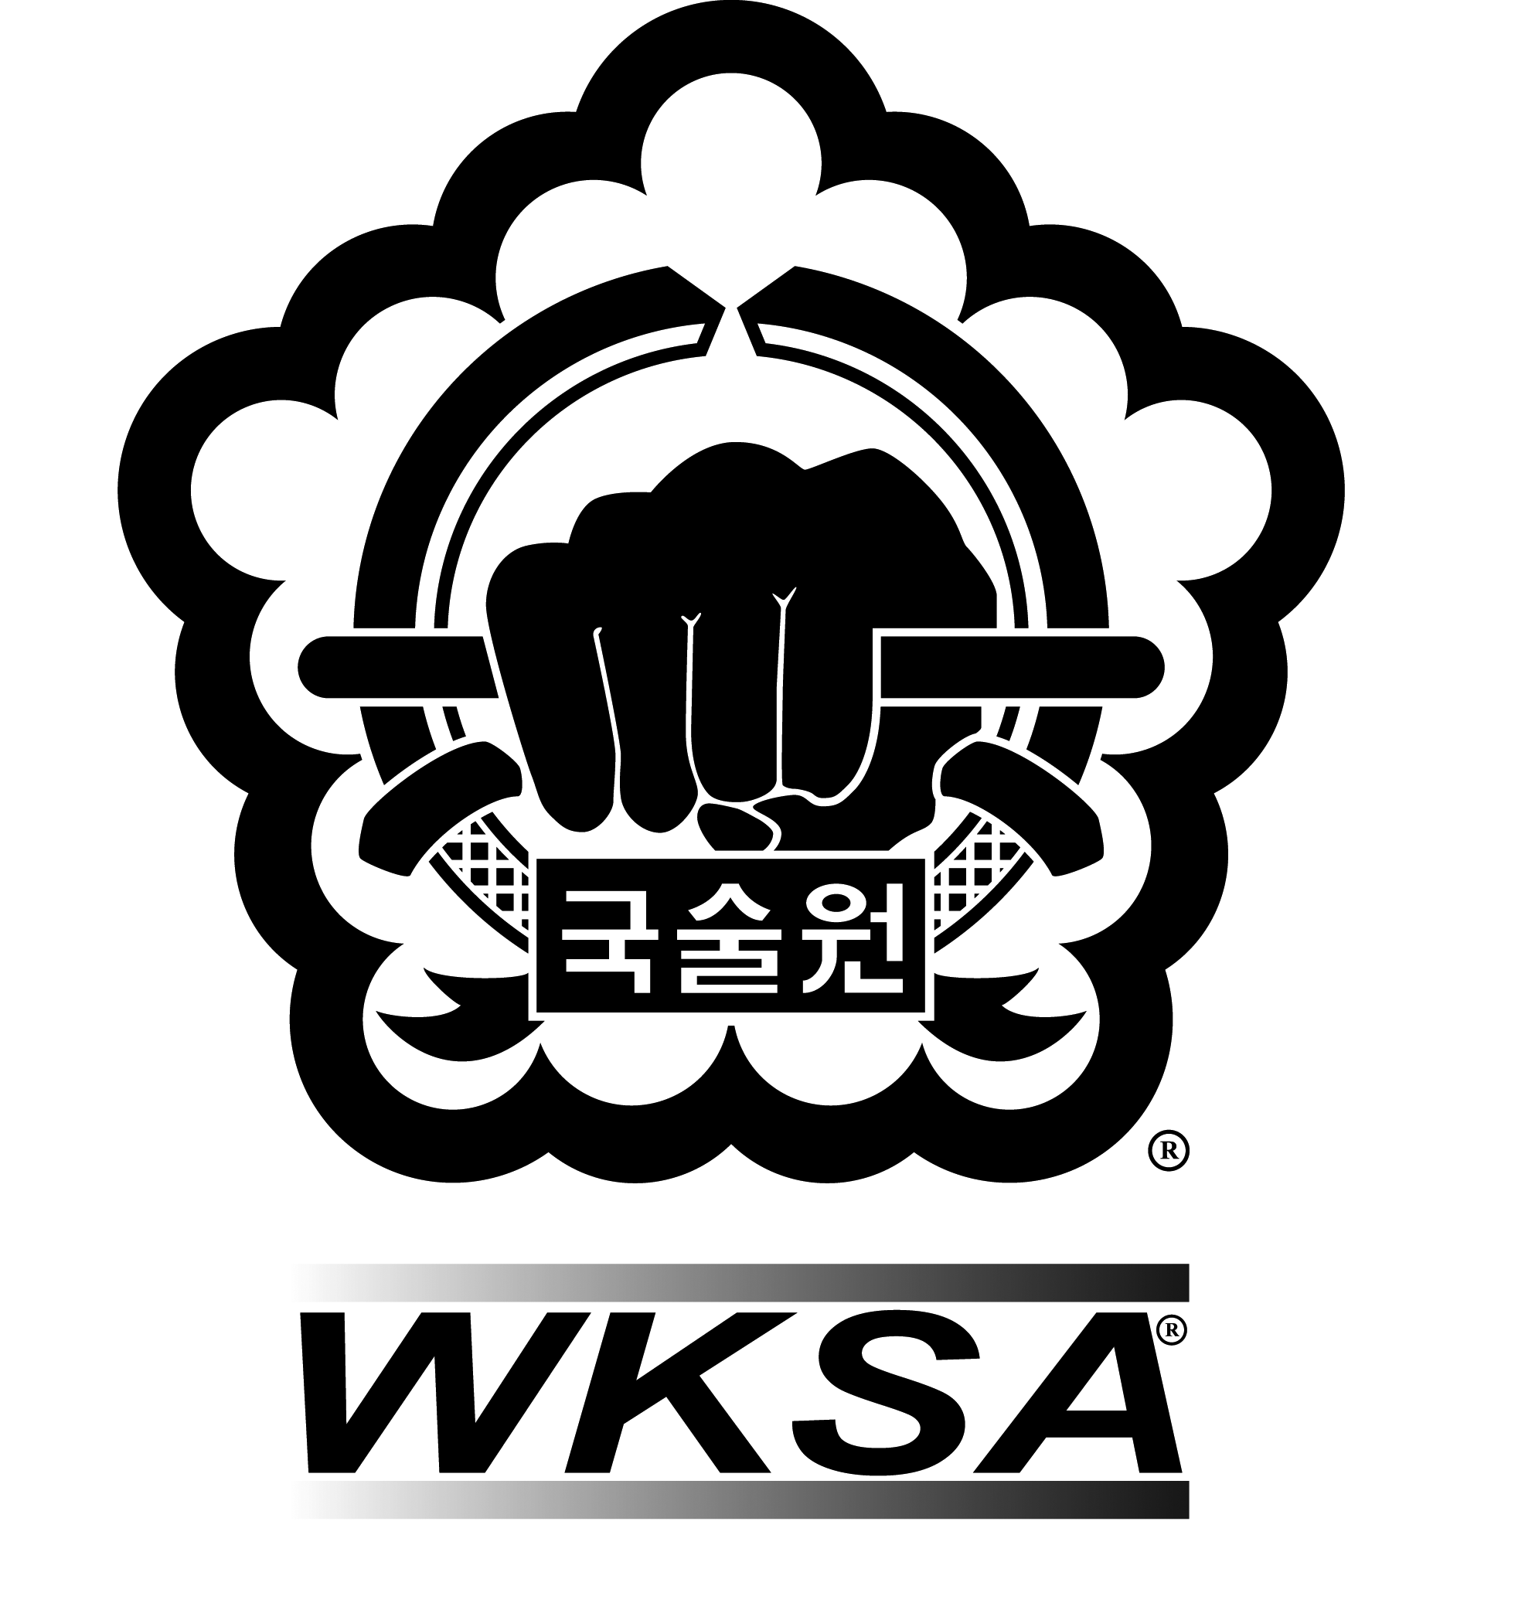

Kuk Sool Won™ of Yeovil Martial Arts

Safe Practice Policy

Kuk Sool Won™ of Yeovil Martial Arts:-
Martial Arts are activities where safe practice is essential to help prevent injury. Children* are particularly vulnerable as they are still developing mentally and physically, so training methods need to be modified as described below. (*also includes Adults at Risk)
- Warm Ups
All activities should first include a thorough warm up which is appropriate for the activity taking place. To help reduce the risk of injury, specific attention should be paid to those muscle groups that will be used during later activity.

- Martial Arts self defence techniques involving throwing, grappling and strangling
The risks include but are not limited to: falling on unsuitable surfaces; landing on the head; damage to the joints from locks; strangulation.
Safe practice should include, but is not limited to:
- Checking the matted area for suitability, particularly where the mats have been joined.

- Checking that there are no hard surfaces or sharp/hard objects around the matted area.

- Having an experience instructor who will ensure that children are not taught to use locks, throws or strangles which will cause injury.

- Skills taught are to appropriate belt grade.

- Martial Arts involving strikes, punches and kicks
The risks include but are not limited to: concussion (brain injury) from heavy blows to the head; damage to internal organs and joints from heavy blows; injury from inappropriate stretching and other exercises.
There are some key points to consider in this section, particularly around head contact for under 16s.
- Sparring is zero to light contact on all target areas
- Full sparring equipment is required in all sparring practices and competitions
- Competitive sparring groups are always age and ability specific and gender specific for 15+
- Competitive sparring always has three judges and two score/time keepers and sparring practices always follow instructor-student ratios

- Competition sparring takes place on hard flooring (helmets are worn in case of fall)
- First aid trained instructors or specialists are always present during sparring practices and competitions

Avoiding excessive stretching and exercises such as press-ups on the knuckles or hitting heavy bags; the joints of children are still developing and can be damaged by these exercises.

- Martial Arts involving weapons
Safe practice should include but is not limited to:
- No live blades (sharp or otherwise) in the training hall when children are
present
- Safe protocols for the use of training weapons by children
- Good supervision at all times by Instructors

Above all, safe practice means having a suitably qualified and experienced instructor who will ensure that children are not exposed to the above risks and who can make a training session enjoyable whilst maintaining the discipline essential to learning a Martial Art.

