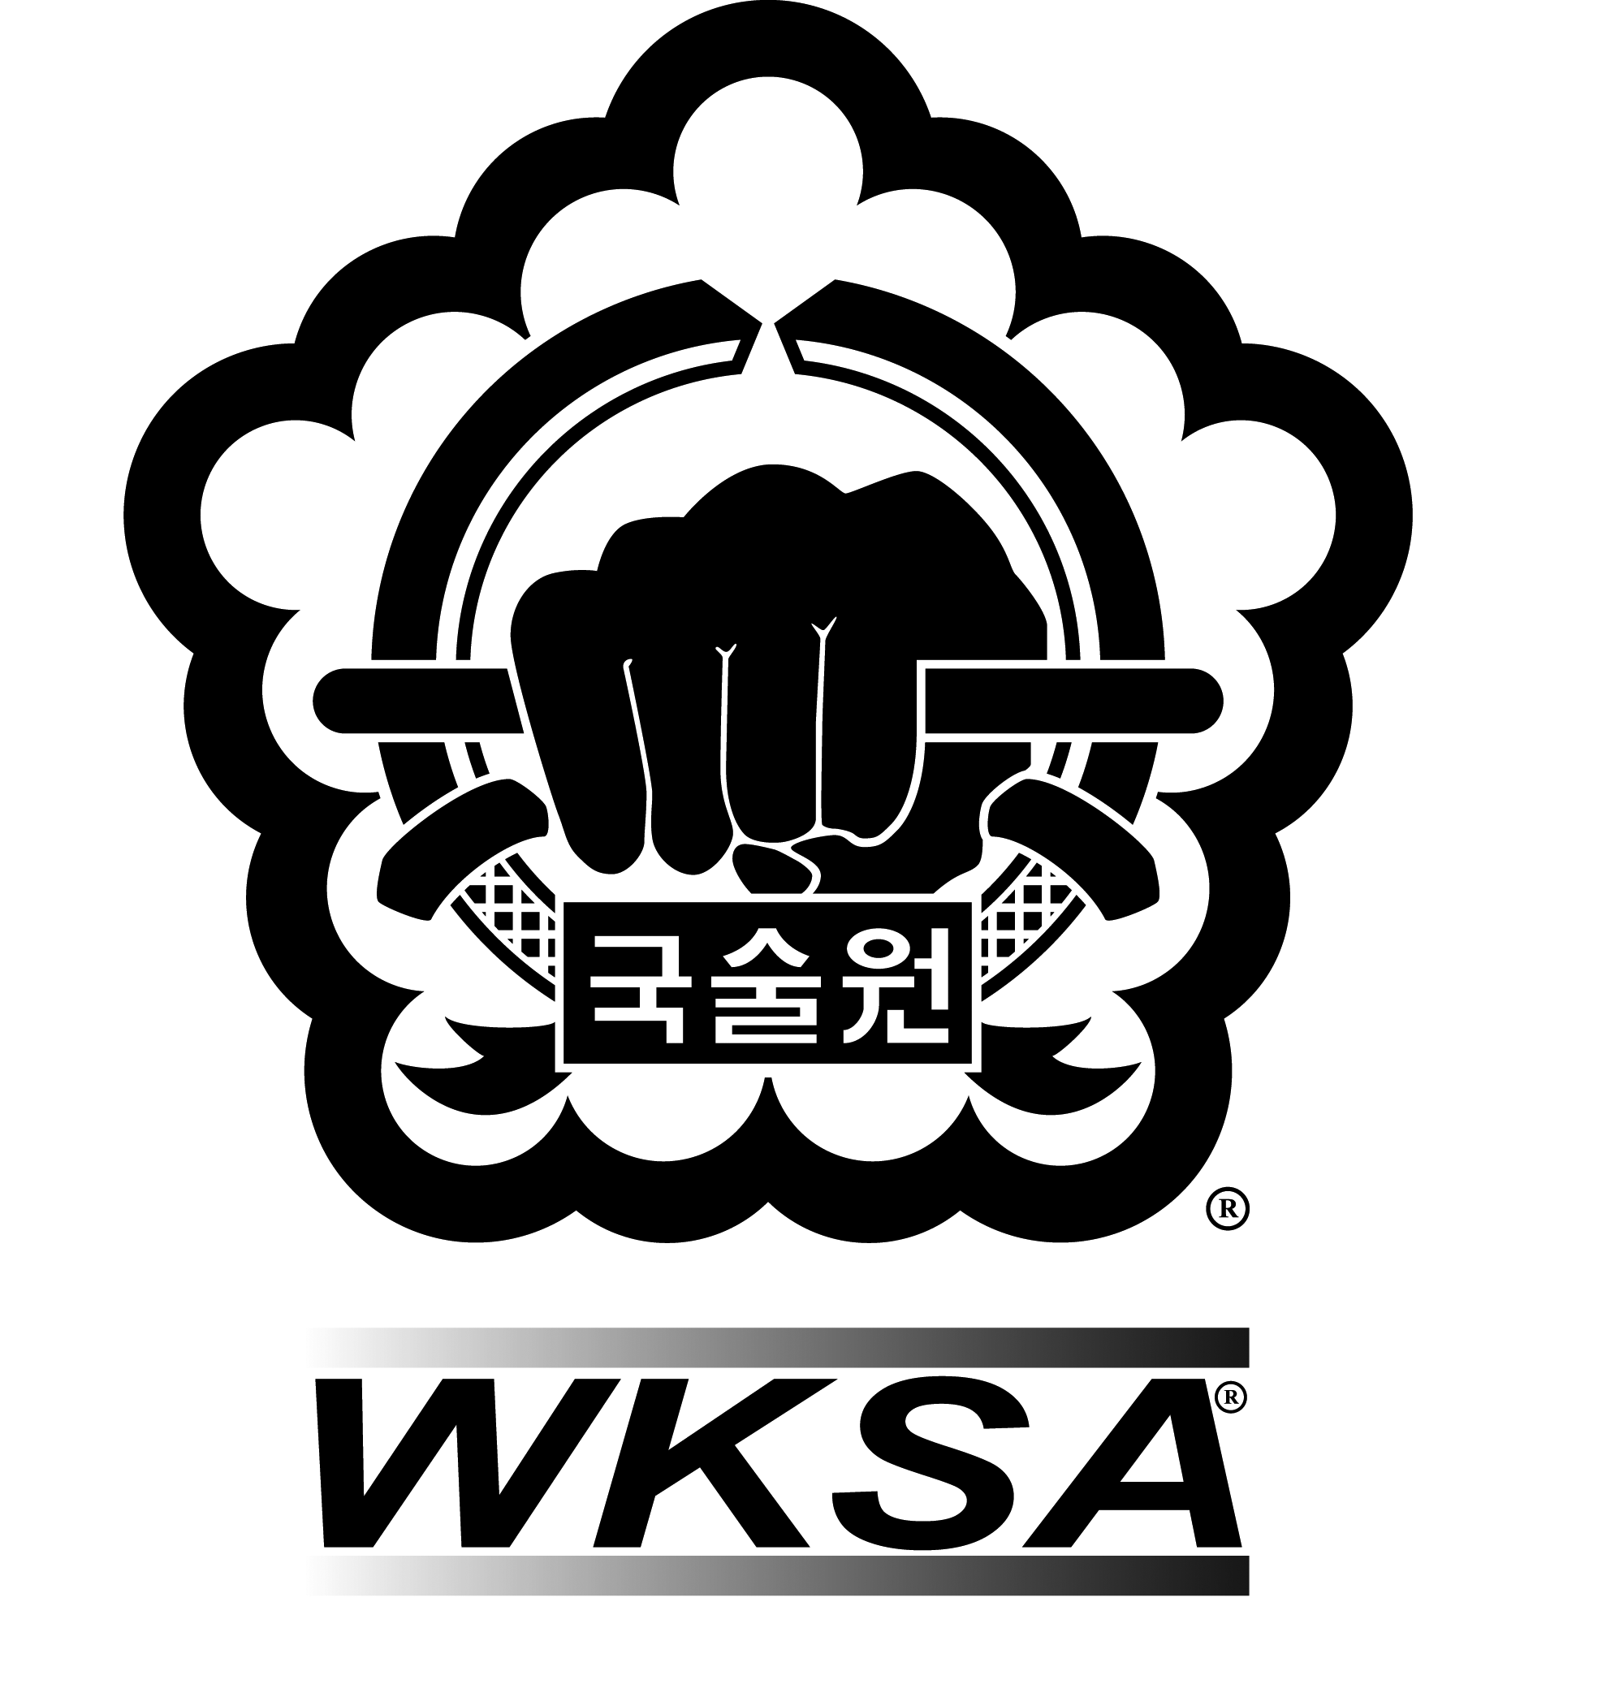

Kuk Sool Won™ of Yeovil Martial Arts

Complaints Procedure

Kuk Sool Won™ of Yeovil Martial Arts are committed to providing a high-quality service to all our participants, children/young people and adults; parents/carers. When something goes wrong, we need you to tell us about it. This will help us to improve our standards.

If you have a complaint, please contact us with the details. We have 28 days to consider your complaint.

What will happen next?

- We will send you a letter acknowledging receipt of your complaint within three days of receiving it, enclosing a copy of this procedure.

- We will then investigate your complaint. This will normally involve passing your complaint to our client care partner who will review your matter file and speak to the member of staff who acted for you.

- We will then invite you to a meeting to discuss and hopefully resolve your complaint. S/he will do this within fourteen days of sending you the acknowledgement letter.

- Within three days of the meeting, we will write to you to confirm what took place and any solutions s/he has agreed with you.

- If you do not want a meeting or it is not possible, we will send you a detailed written reply to your complaint, including his/her suggestions for resolving the matter, within twenty-one days of sending you the acknowledgement letter.

- At this stage, if you are still not satisfied, you should contact us again and we will arrange for a Master within the World Kuk Sool Association to review the matter.

- We will write to you within fourteen days of receiving your request for a review, confirming our final position on your complaint and explaining our reasons.

