Kuk Sool Won™ of Yeovil Martial Arts

Safeguarding Adults Policy

Policy Owner: Kuk Sool Won™ of Yeovil martial arts
Date Policy approved: 24.02.2024
Next review Date: February 2025
Designated Safeguarding Lead: PKJN Sally Runnacles

Mission Statement/Introduction
Kuk Sool Won™ of Yeovil Martial Arts is committed to creating and maintaining a safe and positive environment and accepts our responsibility to safeguard the welfare of all adults involved in martial arts in accordance with the Care Act 2014.

This safeguarding adults policy and procedures apply to all individuals involved in Kuk Sool Won™ of Yeovil Martial Arts.

Kuk Sool Won™ of Yeovil Martial Arts will encourage and support partner organisations, including clubs, counties, suppliers, and sponsors to adopt and demonstrate their commitment to the principles and practice of equality as set out in this safeguarding adults policy and procedures.
Policy statement
Kuk Sool Won™ of Yeovil Martial Arts:

- believes everyone has the right to live free from abuse or neglect regardless of age, ability or disability, sex, race, religion, ethnic origin, sexual orientation, marital or gender status.
- is committed to the six principles of safeguarding adults which includes: empowerment, protection, prevention, proportionality, partnership and accountability. (England)
- is committed to Safeguarding Adults in line with national legislation and relevant local guidelines by ensuring that our activities are delivered in a way which keeps all adults safe by creating and maintaining a safe and positive environment and an open, listening culture where people feel able to share concerns without fear of retribution.
- recognises that health, well-being, ability, disability and need for care and support can affect a person’s resilience. Kuk Sool Won™ of Yeovil Martial Arts recognises that some people experience barriers, for example, communicating concerns or seeking help.
- accepts that we are required to fulfil our duty of care, which means that we must do everything that can be reasonably expected of us to help safeguard and protect people from harm, and to act when we suspect that someone is being harmed, or is at risk of harm.
- is committed to creating a culture of zero-tolerance of harm to adults which necessitates the recognition of adults who may be at risk and the circumstances which may increase risk and being willing to report safeguarding concerns.

Scope
This safeguarding adult policy and associated procedures apply to all individuals involved in Kuk Sool Won™ of Yeovil Martial Arts including participants, and volunteers, visiting instructors and to all concerns about the safety of adults whilst taking part in our organisation, its activities and in the wider community
Purpose
The purpose of this policy is to demonstrate the commitment of Kuk Sool Won™ of Yeovil Martial Arts to safeguarding adults and to ensure that everyone involved in Kuk Sool Won™ of Yeovil Martial Arts is aware of:
- The legislation, policy and procedures for safeguarding adults.
- Their role and responsibility for safeguarding adults.
- What to do or who to speak to if they have a concern relating to the welfare or wellbeing of an adult within the organisation.
Implementation
Kuk Sool Won™ of Yeovil will ensure that:
- All instructors are DBS checked
- All instructors will attend safeguarding adults training to keep their knowledge up to date.
- All activities include an assessment of, and risk to, the safety of all adults from abuse and neglect and designates a person who will be in attendance as a safeguarding lead for that activity
- All instructors will follow a code of conduct when working with adults – insert link to code of conduct
- There is a system in place for receiving and managing concerns
- All instructors are members of the World Kuk Sool Association®
- This policy is available to participants via our website: www.martialartsyeovil.co.uk

Legislation - what is adult safeguarding?
In its wider context, safeguarding adults applies to everyone over the age of 18 and is about:

- protecting an adult’s right to live in safety, free from abuse and neglect.
- people and organisations working together to prevent and stop both the risks and experience of abuse and neglect, while at the same time making sure that the adult’s wellbeing is promoted taking fully into account their views, wishes, feelings and beliefs in deciding on any action.

The practices and procedures within this policy are based on the relevant legislation and government guidance which can be found following this link:

Safeguarding Adults at Risk Key Legislation and Government Initiatives (anncrafttrust.org)

Procedures
Raising and Managing a Concern
Are you concerned about:

Behaviour of an instructor/volunteer
Are either of you at immediate risk of harm now?
NO
Contact:
∗ WKSA UK Safeguarding Team
∗ Somerset Safeguarding Adults Board
∗ Police

YES
Seek help by dialling 999 for police or ambulance.
NO
Share your concerns with the Safeguarding Lead (DSL) for Kuk Sool Won™ of Yeovil martial arts
Yourself or another adult
Are either of you at immediate risk of harm right now?
Or has a criminal offence been committed?

The Safeguarding Lead (DSL) will then follow the safeguarding procedures

The Designated Safeguarding Lead (DSL) should:
- Speak with the adult concerned
- Determine the wishes of the adult concerned to ensure the process is person led and outcome focused.
- Seek external guidance and advice as appropriate (this could include the WKSA UK Safeguarding Team, Adults Safeguarding Team, Active Partnership or Ann Craft Trust)
- Offer support and information for the adult concerned to make informed choices.
- Put measures in place to keep the adult safe during the activity (if appropriate)
- Ask for consent to report the concern to statutory agencies if appropriate.
- Keep the adult informed and involved throughout the process
Key Contact Details
PSBN Sally Runnacles is the Designated Safeguarding Lead (DSL) who responsible for ensuring that this policy is adhered to. They will be responsible for the monitoring and recording of any safeguarding concerns and for ensuring that all concerns are shared with the appropriate authorities. It is not the role of the DSL to investigate, only to gather and share information as appropriate. The DSL can be contacted on 07795117701 or email ksw.yeovil@gmail.com.
Raising and Managing a Concern
Any safeguarding concerns can be reported via the Designated Safeguarding Lead (DSL), PSBN Sally Runnacles
- Any concern that an adult is not safe is taken seriously, responded to promptly, and followed up.
- The DSL will speak to the adult about the issue wherever possible, noting any views that the adult may have regarding how they wish the matter to be dealt and keeping them informed throughout the process.
- The DSL may seek advice from external sources such as the local Safeguarding Adults Team, the Local Active Partnership, police, WKSA UK Safeguarding Team, Safeguarding Code for Martial Arts or Ann Craft Trust.
- The DSL will only share information with the people who need to know – such as the Safeguarding Adults Team, police or local Active Partnership. Any referrals or passing on of information will be done with the consent of the adult wherever possible. If consent is withheld, but information is still passed on, the DSL will clearly document this and the reasons why. They will also inform the adult of this action wherever possible.
- The DSL will make a written record of the concern and store it safely in line with Data Protection requirements.
Note:
- If someone is injured or at immediate risk, immediate action should be taken. By seeking help by dialling 999 for police or ambulance.
- If someone does not give consent, advice as to what the DSL should do will be sought from either the police, WKSA UK Safeguarding Team, Safeguarding Code for Martial Arts or Ann Craft Trust etc, whilst keeping the name anonymous

Whistleblowing

We strive to encourage sport and activity organisations to be fit of purpose and have and promote good safeguarding adults practice.

If the Safeguarding Lead or an instructor of Kuk Sool Won™ of Yeovil martial arts is implicated or you think has a conflict of interest, then contact either:

Somerset Safeguarding Adults Board:
Telephone (Monday to Friday - 8.30am to 5.00pm) on 0300 123 2224
Email: adults@somerset.gov.uk
Emergencies: 999
or another member of the WKSA UK Safeguarding Team:
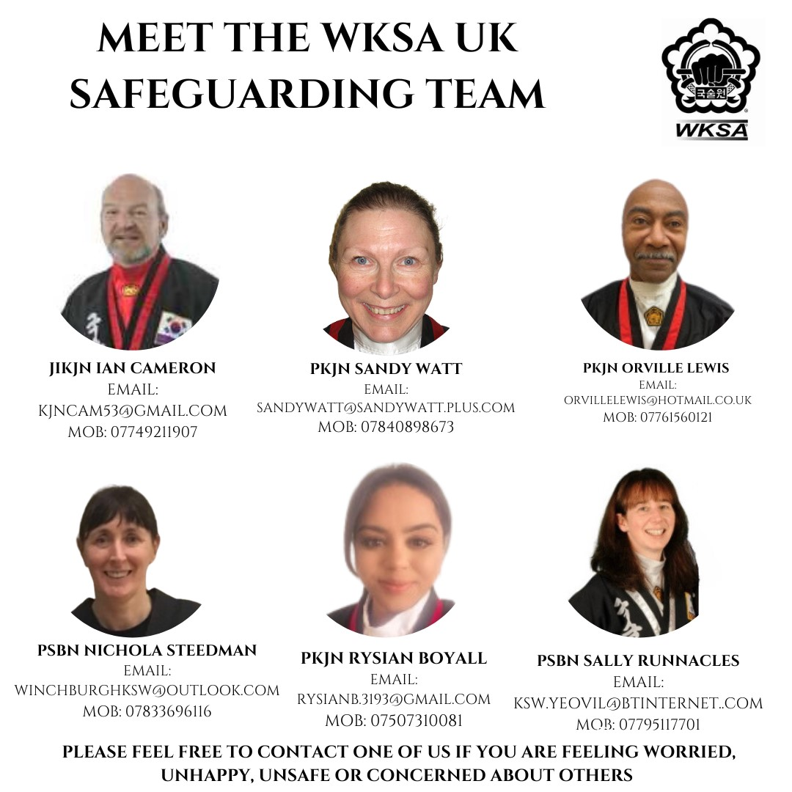

Recording and Information Sharing
GDPR and Data protection
We work to the Seven Golden Rules:
- GDPR is not a barrier to sharing information
- Be open and honest
- Seek advice, if in doubt
- Share with consent where appropriate
- Consider safety and wellbeing
- Necessary, proportionate, relevant, accurate, timely and secure
- Keep a record of your decision and reasons for sharing

Sources of Information and Support

Somerset Safeguarding Adults Board:
Telephone (Monday to Friday - 8.30am to 5.00pm) on 0300 123 2224
Email: adults@somerset.gov.uk
Emergencies: 999
WKSA UK Safeguarding Team:

Action on Elder Abuse
A national organisation based in London. It aims to prevent the abuse of older people by raising awareness, encouraging education, promoting research and collecting and disseminating information.
Tel: 020 8765 7000
Email: enquiries@elderabuse.org.uk
www.elderabuse.org.uk

Ann Craft Trust
A national organisation providing information and advice about adult safeguarding. The Ann Craft Trust has a specialist Safeguarding Adults in Sport and Activity team to support the sector
Tel: 0115 951 5400
Email: Ann-Craft-Trust@nottingham.ac.uk
www.anncrafttrust.org

Men’s Advice Line
For male domestic abuse survivors
Tel: 0808 801 0327

National LGBT+ Domestic Abuse Helpline
Tel: 0800 999 5428

National 24Hour Freephone Domestic Abuse Helplines

England | Northern Ireland
Tel: 0808 2000 247  www.nationaldahelpline.org.uk/Contact-us | Tel: 0808 802 1414  www.dsahelpline.org  Twitter: www.twitter.com/dsahelpline  Facebook: www.facebook.com/dsahelpline
Scotland | Wales
Tel: 0800 027 1234  Email: helpline@sdafmh.org.uk  Web chat: sdafmh.org.uk | Llinell Gymorth Byw HebOfn/ Live free from fear helpline  Tel: 0808 8010 800  Type Talk: 18001 0808 801 0800  Text: 078600 77 333

Rape Crisis Federation of England and Wales
Rape Crisis was launched in 1996 and exists to provide a range of facilities and resources to enable the continuance and development of Rape Crisis Groups throughout Wales and England.
Email: info@rapecrisis.co.uk
www.rapecrisis.co.uk

Respond
Respond provides a range of services to victims and perpetrators of sexual abuse who have learning disabilities, and training and support to those working with them.
Tel: 020 7383 0700 or
0808 808 0700 (Helpline)
Email: services@respond.org.uk
www.respond.org.uk

Stop Hate Crime
Works to challenge all forms of Hate Crime and discrimination, based on any aspect of an individual’s identity. Stop Hate UK provides independent, confidential and accessible reporting and support for victims, witnesses and third parties.
24 hours service:
Telephone: 0800 138 1625
Web Chat: www.stophateuk.org/talk-to-us/
E mail: talk@stophateuk.org
Text: 07717 989 025
Text relay: 18001 0800 138 1625
By post: PO Box 851, Leeds LS1 9QS

Susy Lamplugh Trust
The Trust is a leading authority on personal safety. Its role is to minimise the damage caused to individuals and to society by aggression in all its forms – physical, verbal and psychological.
Tel: 020 83921839
Fax: 020 8392 1830
Email: info@suzylamplugh.org
www.suzylamplugh.org
Victim Support
Provides practical advice and help, emotional support and reassurance to those who have suffered the effects of a crime.
Tel: 0808 168 9111
www.victimsupport.com
Women’s Aid Federation of England and Wales
Women’s Aid is a national domestic violence charity. It also runs a domestic violence online help service.
www.womensaid.org.uk/information-support

