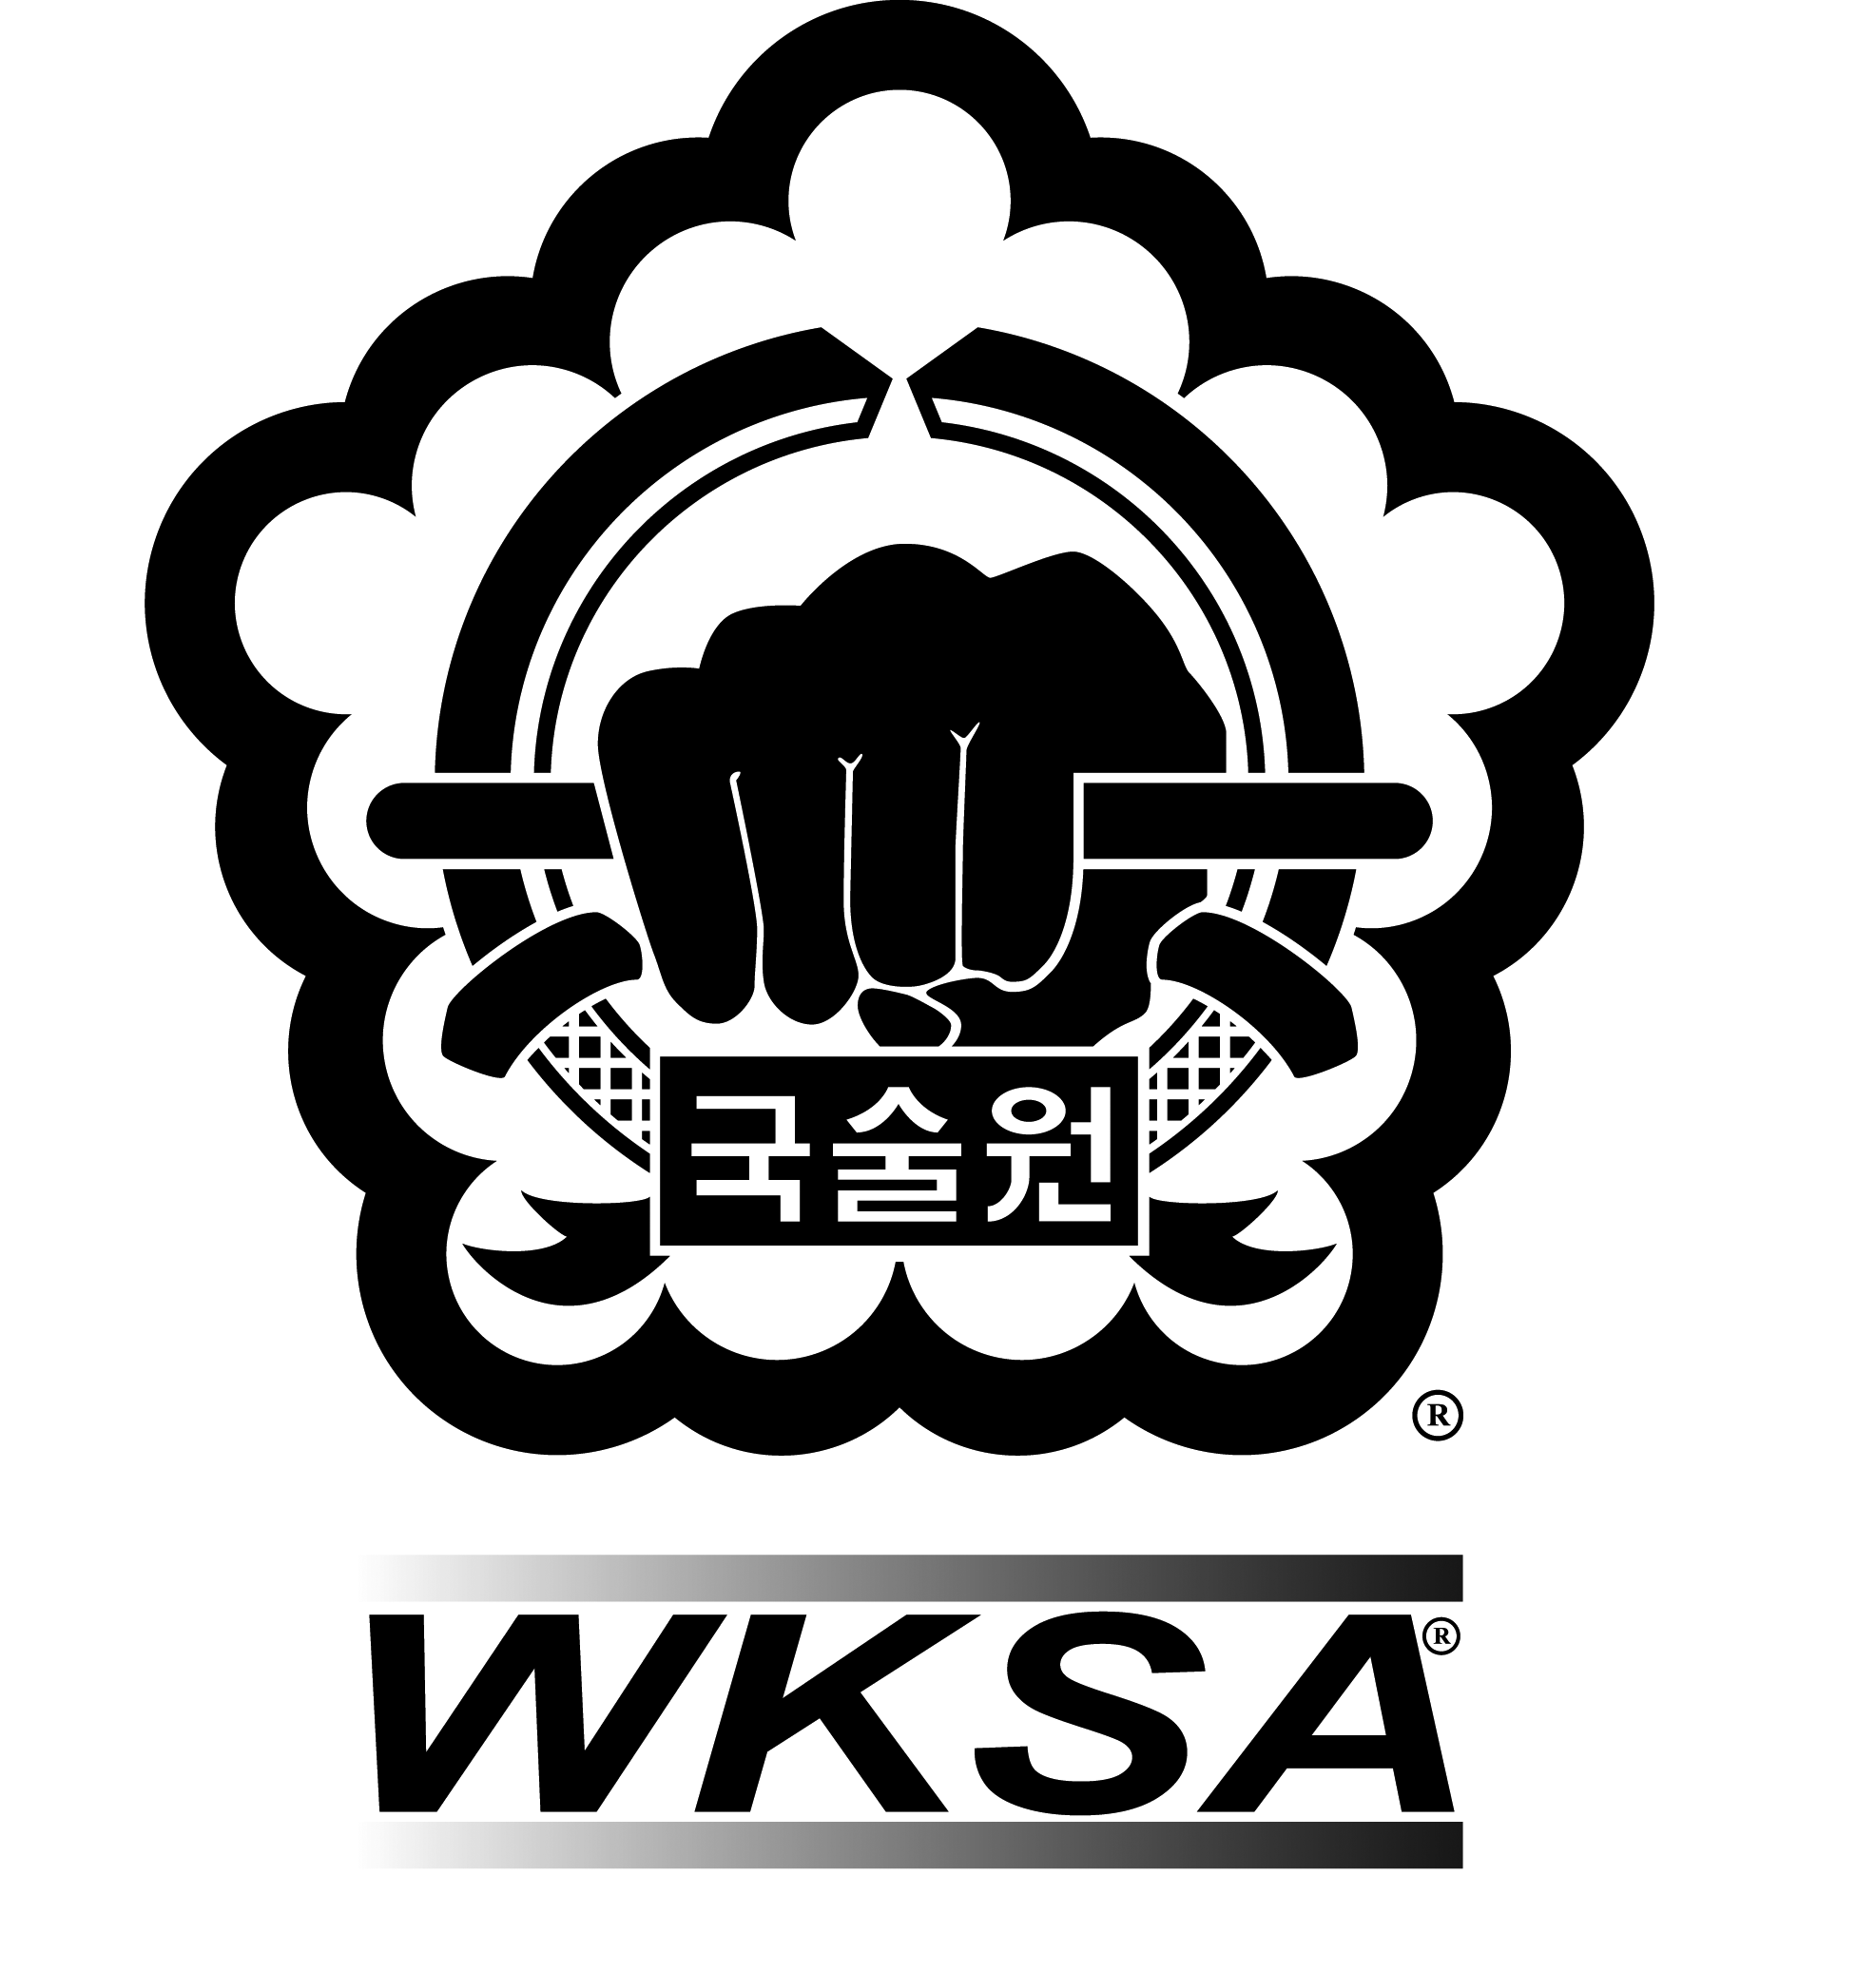

Kuk Sool Won™ of Yeovil Martial Arts
Safeguarding Policy Statement

Note: The terms ‘child’ and ‘young person’ describe any person under the age of 18. References to ‘parents’ should be read as parents and carers inclusively.
Our statement
Our organisation acknowledges the duty of care to safeguard and promote the welfare of children and is committed to ensuring safeguarding practice reflects statutory responsibilities, government guidance and complies with best practice and requirements of the World Kuk Sool Association® (“WKSA”).
The policy recognises that the welfare and interests of children are paramount in all circumstances. It aims to ensure that regardless of age, ability or disability, gender reassignment, race, religion or belief, sex or sexual orientation, socio-economic background, all children:
- have a positive and enjoyable experience of sport at Kuk Sool Won™ of Yeovil Martial Arts in a safe and child centred environment
- are protected from abuse whilst participating in Kuk Sool Won™ of Yeovil Martial Arts or outside of the activity.
We acknowledge that some children, including disabled children or those from ethnic minority communities, can be particularly vulnerable to abuse and we accept the responsibility to take reasonable and appropriate steps to ensure their welfare.
Our Policy
What we will do:
As part of our safeguarding policy, we will:
- promote and prioritise the safety and wellbeing of children and young people
- value, listen to and respect children
- ensure robust safeguarding arrangements and procedures are in operation
- adopt safeguarding best practice through our policies, procedures and code of conduct for staff and volunteers
- ensure everyone understands their roles and responsibilities in respect of safeguarding and is provided with appropriate learning opportunities to recognise, identify and respond to signs of abuse, neglect and other safeguarding concerns relating to children and young people
- provide effective management for staff and volunteers through supervision, support, training and quality assurance measures so that all staff and volunteers know about our policies, procedures and behaviour codes and follow them confidently and competently
- ensure appropriate action is taken in the event of incidents or concerns of abuse and support provided to the individual(s) who raise or disclose the concern
- ensure that confidential, detailed and accurate records of all safeguarding concerns are maintained and securely stored record and store information securely, in line with data protection legislation and guidance
- prevent the employment or deployment of unsuitable individuals by recruiting and selecting staff and volunteers safely, ensuring all necessary checks are made
- appoint a nominated safeguarding lead for children and young people, a deputy and a lead trustee/board member for safeguarding
- develop and implement an effective online safety policy and related procedures
- share information about safeguarding and good practice with children and their parents via leaflets, posters, group work and one-to-one discussions
- make sure that children, young people and their parents know where to go for help if they have a concern
The policy and procedures will be widely promoted and are mandatory for everyone involved in Kuk Sool Won™ of Yeovil Martial Arts. Failure to comply with the policy and procedures will be addressed without delay and may ultimately result in dismissal or exclusion from the organisation.
Monitoring
This policy will be reviewed a year after development and then every three years, or in the following circumstances:
- changes in legislation and/or government guidance
- as required by the local safeguarding partnership, UK Sport and/or home country sports councils and WKSA
- as a result of any other significant change or event.

This policy was last reviewed on 24.02.2024/18.02.2023
Signed: Sally Runnacles
Safeguarding Officer for Kuk Sool Won™ of Yeovil Martial Arts

Contact details:
Our Safeguarding/Welfare Officer
Name: PSBN Sally Runnacles
Tel: 07795117701
Email: ksw.yeovil@gmail.com

Our Deputy Safeguarding/Welfare Officer
Name: PKJN Stephen Runnacles
Tel: 07842996280
Email: ksw.yeovil@btinternet.com
In a safeguarding emergency,
where a young person is at immediate risk of harm,
call 999

